**Unit 2 Diagnostic Test**

1.

A ball is stationary on a flat frictionless surface and then is pushed in two ways on the surface (Case I and Case II). The forces shown act for 10 seconds, and then the ball rolls freely. Consider the speed of the ball when it is rolling freely after the forces are applied.

1 N

1 N

F

45°

CASE I

CASE II

For the ball in Case II to move at the same speed as the ball in case I

 ______

 ______

 ______

 ______

 ______

is impossible because a force at an angle cannot produce the same result as horizontal and vertical forces ______

2.

A ball of weight W is kept in equilibrium by two cords. In cases 1 and 2, the cords are oriented at different angles as shown. The tensions are denoted as T1 for case 1 and T2 for case 2.

Ceiling

70°

25°

70°

Ceiling

T1

T2

T1

25°

T2

W

W

How are the tensions in the two cases related to each other?

T1 < T2 _____ T1 = T2 ______ T1 > T2 ______

Explain your answer.

3.

A 10 lb truck with freely spinning wheels is kept in equilibrium on a 20° ramp with a spring scale oriented parallel to the ramp.

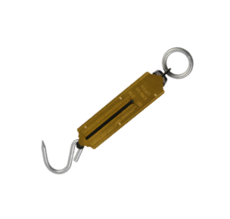

20°

Circle the correct direction of the force of the ramp on the truck.

The magnitude of the force of the ramp on the truck is:

10 lb ______

(10 lb) cos 20° ______

(10 lb) sin 20° ______

(10 lb)/cos 20° ______

(10 lb)/sin 20° ______

4.

A 10 lb block rests on a table. The static coefficient of friction between the table and the block is s = 0.3. A finger pushes on the block with a force of 1 lb.

1 lb

Circle one of the following to indicate the direction of the friction force or if there is none.

No friction force

What is the magnitude of the friction force?

0 ______

1 lb ______

2 lb ______

3 lb ______

4 lb ______

Cannot be determined ______